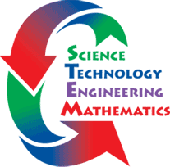

Tuesday, October 22, 2013

6:30 to 7:30 PM

Springfield Middle School Cafeteria

Learn what STEM Education is about and have fun as a family while you complete two hands-on STEM challenges. Contact Mr. Bartholomew with questions.

[barthkev@wcps.k12.md.us](mailto:barthkev@wcps.k12.md.us)

**Book Fair** will be open from **3:30 to 6:30 PM** in the media center.

**STEM FAMILY NIGHT**

**Join Us For:**